ASSIGMENT : UNIT 4
NAME : PRIYANSHI
ROLL NO : 25010216
COURSE : BTECH CSE(core)
SECTION : A
SUBJECT : COMPUTATIONAL SCIENCE FUNDAMENTALS AND CAREER PATH WAYS
SUBMITTED TO: MR. RAJESH BANDRA
INTRODUCTION
I
This project is a static portfolio website created using clean, structured HTML to display sections like About, Projects, Skills, and Contact.
The design is styled using CSS, including layout formatting, tables, buttons, sticky header, and a fixed Back-to-Top button.
It showcases my learning in web development, focusing on page structure, styling, and basic responsiveness.
The project is created as part of my B.Tech CSE assignment and managed using VS Code, Git, and GitHub.
INSTALLATION OR TO RUN
Clone the repository:
git clone [https://github.com/priyanshi220383-max/CSFAC-assig-4.git](https://github.com/priyanshi220383-max/CSFAC-assig-4.git)
Navigate to the folder:
cd CSFAC-assig-4
Run the application:
simply double-click portfolio.html to open it in your default web browser.
alternatively we can use "Live server" extension in VS Code.
SCREENSHOTS
Desktop View
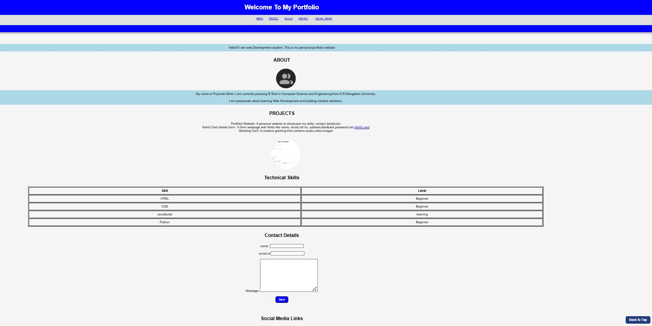
KEY FEATURES

Structured HTML Layout
The website is built using clean and organized HTML containing well-defined sections such as About, Projects, Skills, Contact, and Social Media, allowing easy navigation and readability.
Sticky Navigation Header
A blue sticky header is implemented using CSS (position: sticky; top: 0;), ensuring the navigation bar always stays visible while scrolling.

Styled Tables and Buttons
Technical Skills are displayed using a centered table, and interactive elements like buttons are styled with CSS for better user experience.

Responsive Layout with Media Query Support
The CSS structure is designed to support future responsive design, where media queries can easily be added to adapt the layout for mobile screens.

Back-to-Top Floating Button
A fixed-position “Back to Top” button is added at the bottom-right corner using CSS, allowing users to return to the top of the webpage easily.

Circular Profile Image
The About section features a profile picture styled with border-radius: 50% to create a perfect circular image, enhancing the design.

Clean Typography and Color Theme
The website uses Arial font, light background colors, and a consistent color theme combining blue and white for a smooth and professional appearance.

Center-Aligned Content
Most elements such as text, images, and tables are center-aligned, creating a balanced and simple visual layout suitable for beginners.
USAGE INSTRUCTION
To view and test this Portfolio Website, the following steps were followed:
- Environment: Any web browser (Chrome recommended).
- Execution:
  - Open the project folder in VS Code.
  - Simply open index.html in a browser to run the webpage.
- Editing:
All changes to structure and design were done in index.html and style3.css.
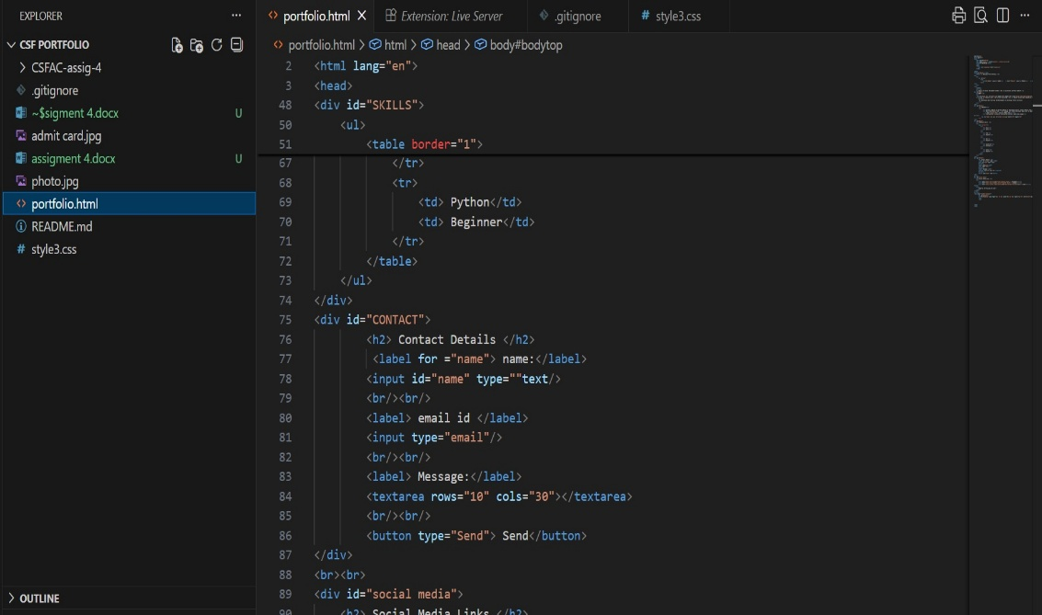

Development Process and Tools
The project was fully developed in Visual Studio Code, using its terminal to perform Git operations.
Git Workflow
A systematic 5-commit workflow was followed to document the project development properly:

Commit 1 – Project Initialization
- Created the basic file structure: index.html, style3.css, .gitignore, and README.md.
- Initialized Git using git init.

Commit 2 – HTML Skeleton Complete
- Added all major sections (About, Projects, Skills, Contact, Social Media).
- Inserted images, links, and layout structure.

Commit 3 – CSS Design & Styling
- Designed the full layout using CSS (sticky header, tables, buttons, background, etc.).
- Added Back-to-Top button styling.

Commit 4 – Documentation Added
- Updated README.md with project intro, features, how to run, and screenshots.
- Created documentation files inside /docs.

Commit 5 – Final Review & Submission
- Reviewed all files, fixed formatting, added alt text for images, and pushed final version to GitHub.
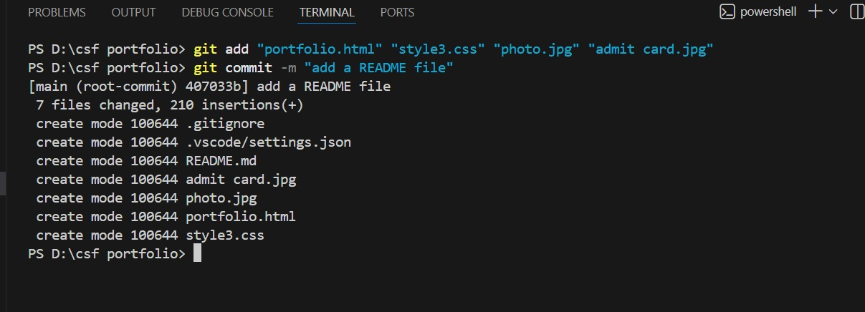
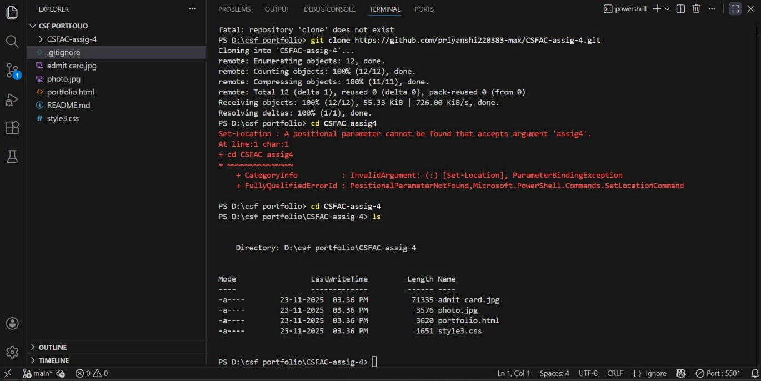
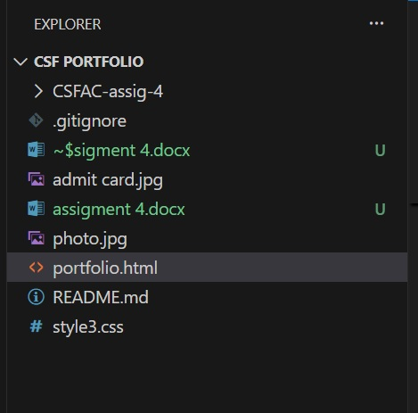

Conclusion and Submission Proof
The Portfolio Website successfully demonstrates the required learning outcomes:

- Creating a structured static webpage using HTML
- Styling elements with CSS
- Using VS Code, Git, and GitHub effectively
- Maintaining a clean commit history and proper documentation

GitHub Repository Link: https://github.com/priyanshi220383-max/CSFAC-assig-4.git

